EE 5351 DIGITAL VIDEO CODING

ASSIGNMENT 3 LZ77 ALGORITHM

NAME: PAVAI ARCHIMEDES

UT ID:1001233996

Apply a 1-D LZ77 coding scheme to JPEG lossless compression system. Show the work of your system for grey scale images.

System requirements

1. Your output from the decoder must be exactly the same as the original.

2. Use search buffer which has size equals to 10 plus the last digit of your ID.

3. Select 2 prediction modes specified in the JPEG standard to compress

(JPEG lossless system can be developed from jpegll-enc.c and jpegll-dec.c )

GENERATION OF IMAGES FOR MODE 1:

EARTH IMAGE:

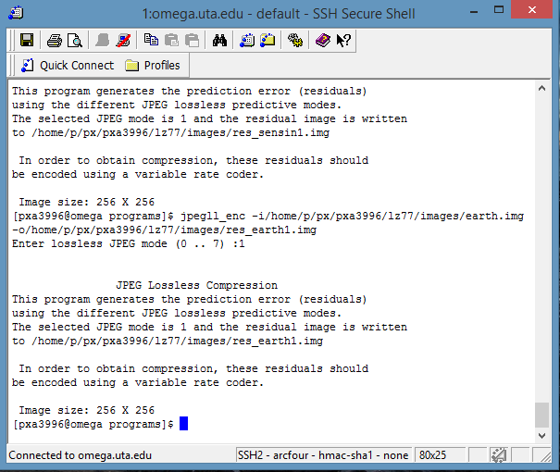

SENA IMAGE:

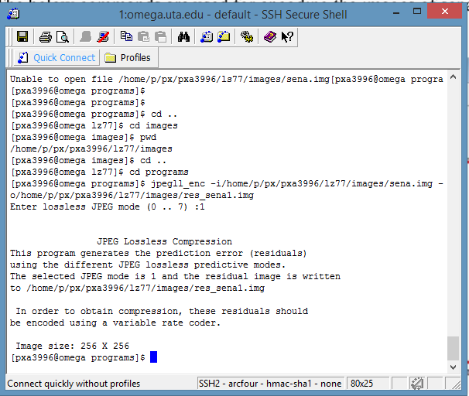

OMAHA IMAGE:

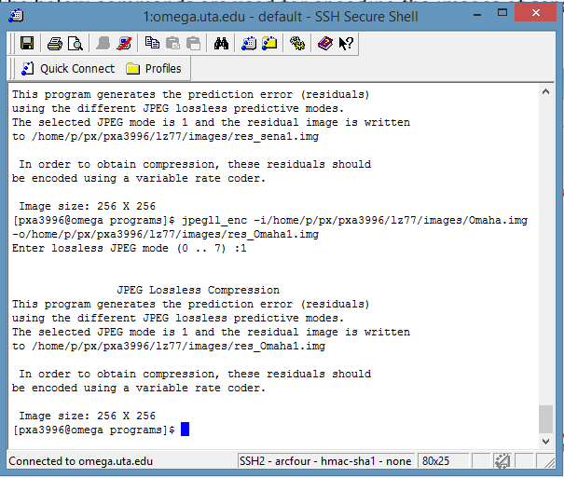

SENSIN IMAGE:

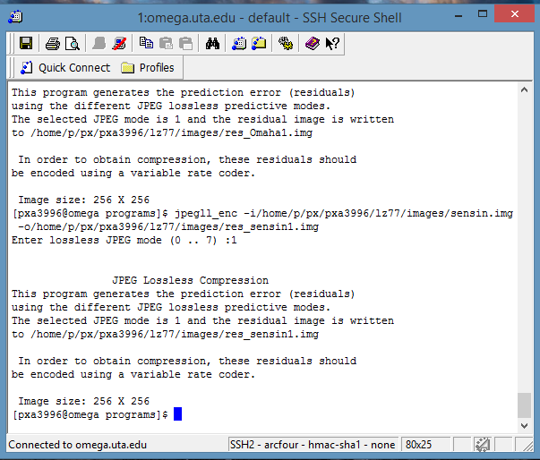

GENERATION OF MODE 2 IMAGES:

EARTH IMAGE:

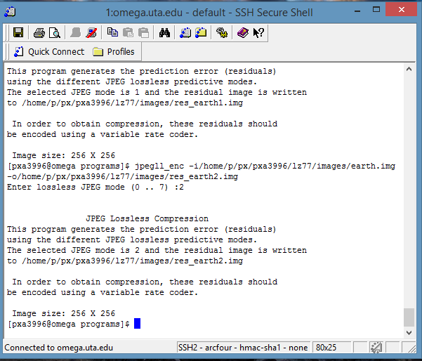

SENA IMAGE:

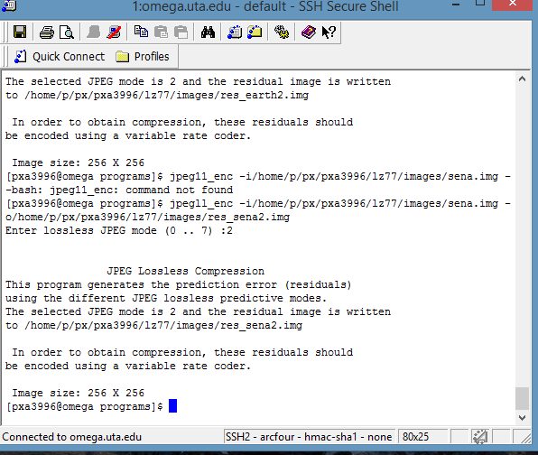

OMAHA IMAGE:

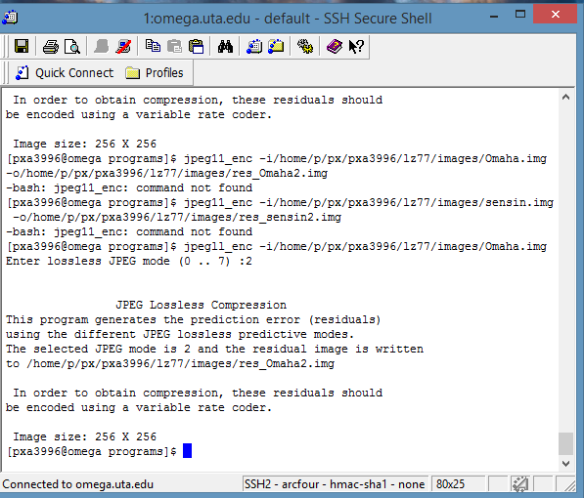

SENSIN IMAGE:

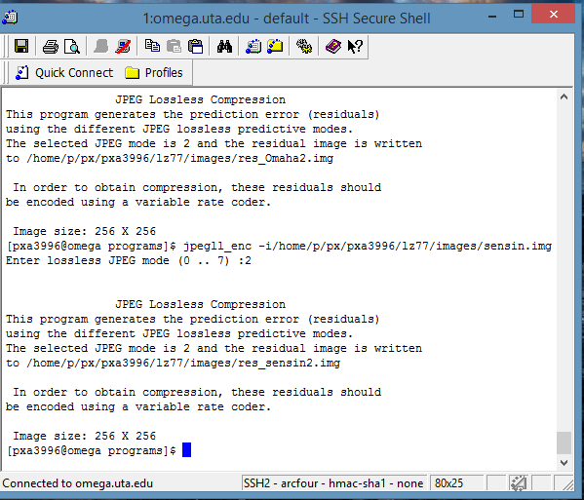

AFTER GENERATION OF TWO MODES OF IMAGES:

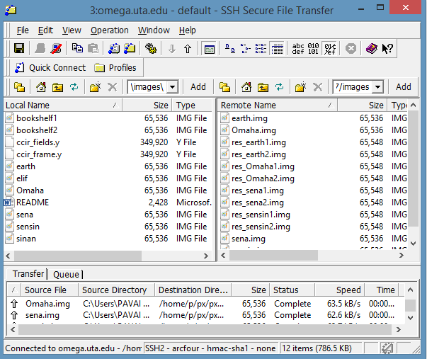

RESULTS IN COMMAND WINDOW:

1. ENCODING PART OF MODE 1 IMAGES:

EARTH:

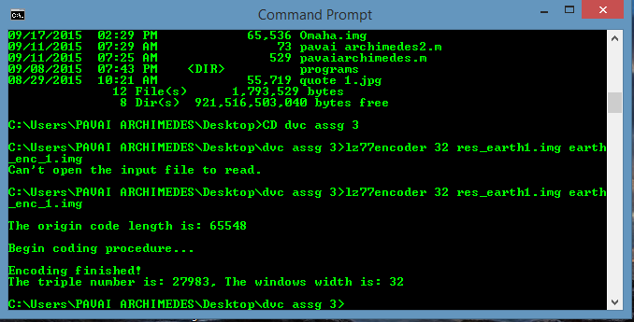

OMAHA:

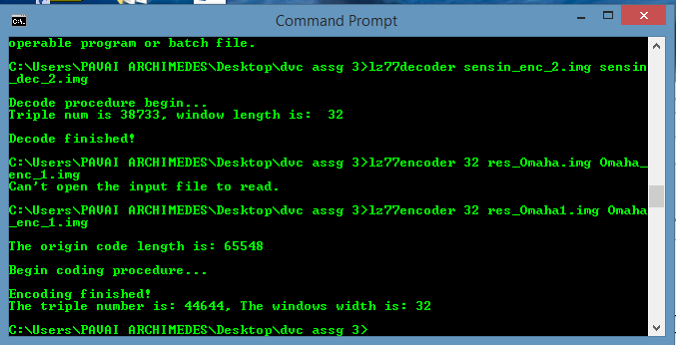

SENA:

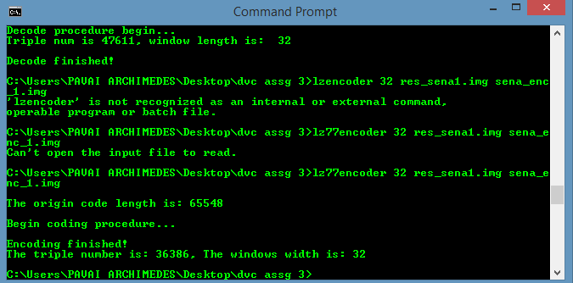

SENSIN:

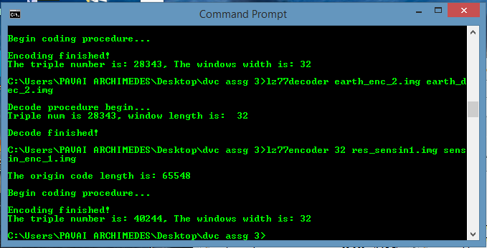

1. DECODING PART OF MODE1 IMAGES:

EARTH:

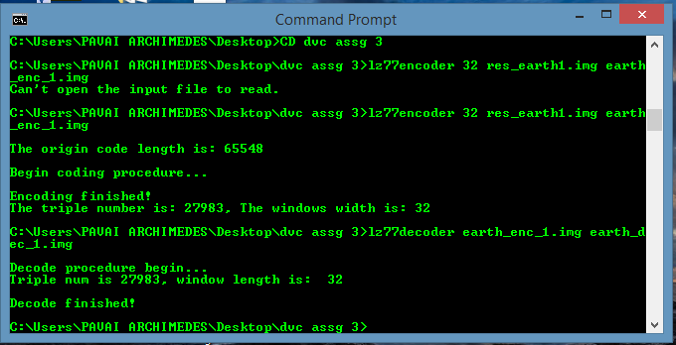

OMAHA:

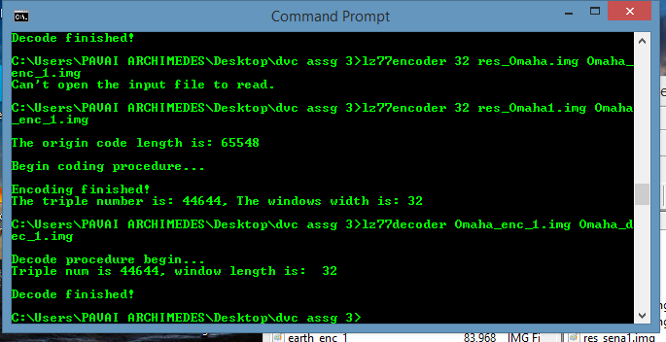

SENA:

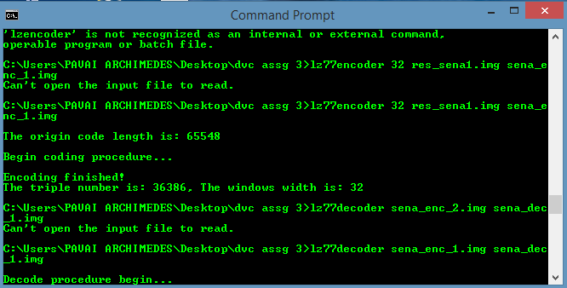

SENSIN:

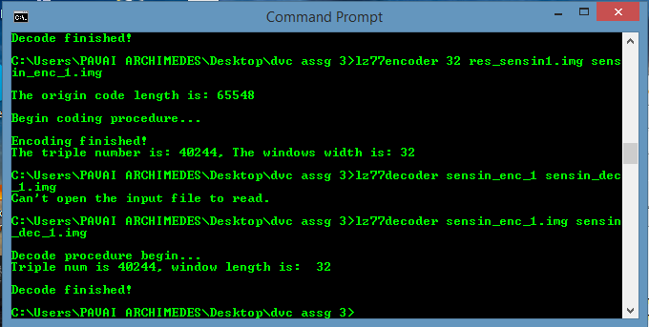

1. ENCODING RESULTS OF MODE2 IMAGES:

EARTH:

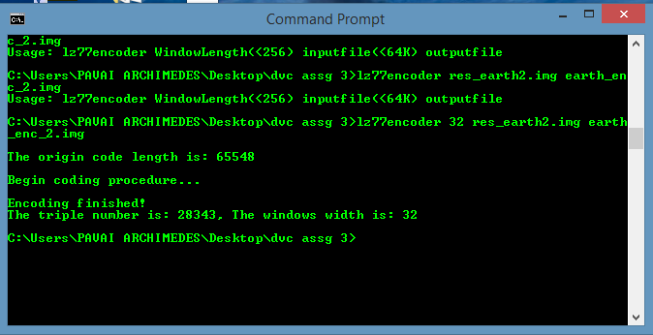

OMAHA:

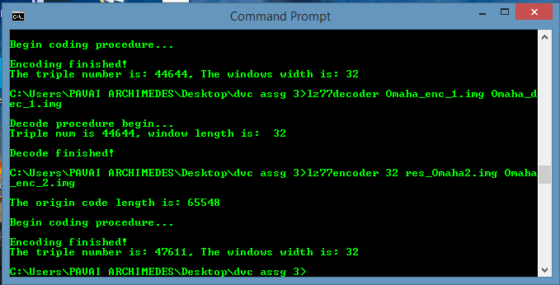

SENA:

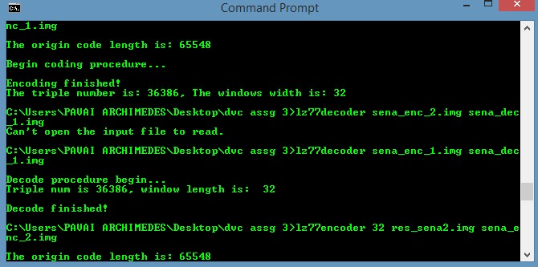

SENSIN:

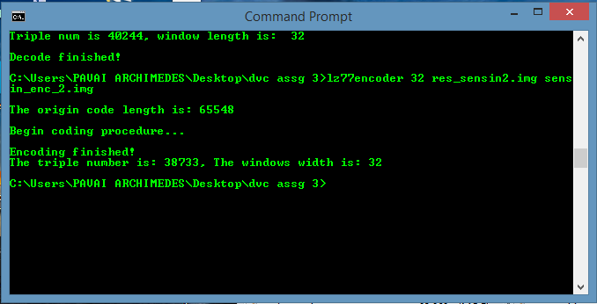

1. DEC ODING RESULTS OF MODE 2 IMAGES:

EARTH:

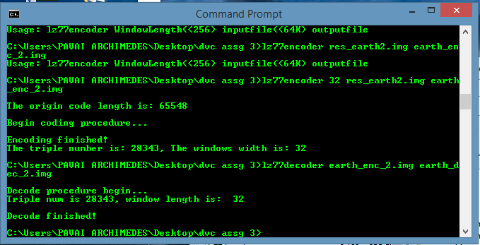

OMAHA:

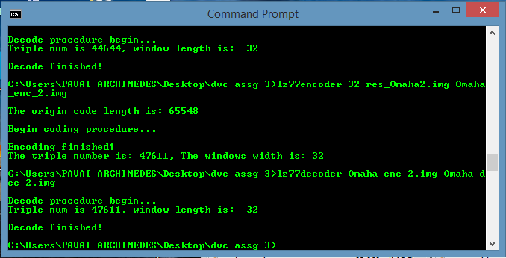

SENA:

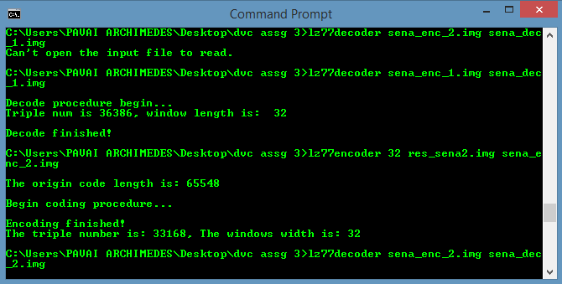

SENSIN:

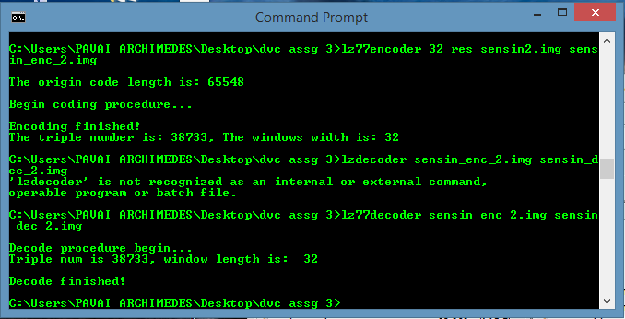

FINAL RESULTS AFTER ENCODING AND DECODING IMAGE:

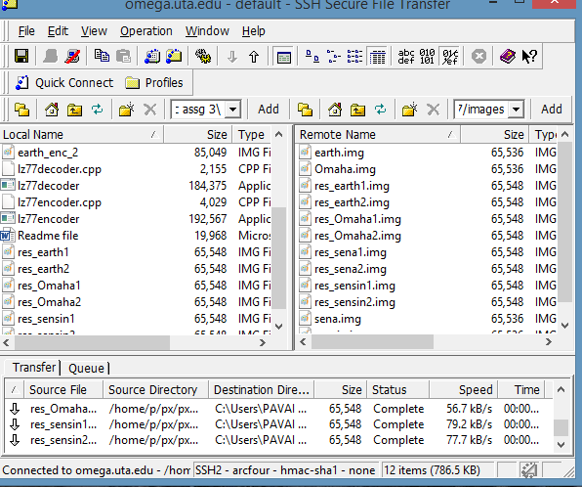

COMPARISON CHART:

|  |  |  |  |  |
| --- | --- | --- | --- | --- |
| **Image** | **Sena Image**  **Mode 1** | **Sensin Image**  **Mode 1** | **Omaha Image**  **Mode 1** | **earth Image**  **Mode 1** |
| **Original Image**  **Size in bytes** | 65,536 | 65,536 | 65,536 | 65,536 |
| **Residual Image**  **Size in bytes** | 65,548 | 65,548 | 65,548 | 65,548 |
| **Encoded Image**  **Size in bytes** | 108,189 | 118,612 | 132,128 | 83,112 |
| **Decoded Image**  **Size in bytes** | 65,548 | 65,548 | 65,548 | 65,548 |
| **Reconstructed Image Size in bytes** | 65,536 | 65,536 | 65,536 | 65,536 |

|  |  |  |  |  |
| --- | --- | --- | --- | --- |
| **Image** | **Sena Image**  **Mode 2** | **Sensin Image**  **Mode 2** | **Omaha Image**  **Mode 2** | **earth Image**  **Mode 2** |
| **Original Image**  **Size in bytes** | 65,536 | 65,536 | 65,536 | 65,536 |
| **Residual Image**  **Size in bytes** | 65,548 | 65,548 | 65,548 | 65,548 |
| **Encoded Image**  **Size in bytes** | 98,571 | 115,056 | 141,858 | 84,051 |
| **Decoded Image**  **Size in bytes** | 65,548 | 65,548 | 65,548 | 65,548 |
| **Reconstructed Image Size in bytes** | 65,536 | 65,536 | 65,536 | 65,536 |

CONCLUSION:

By observing the above tabular forms we can deduce that there is a lossless jpeg compression.